

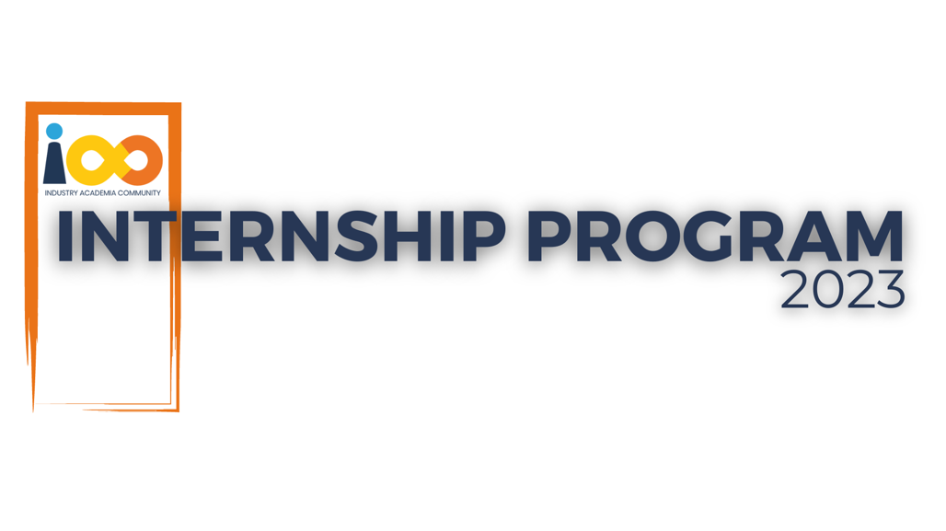

PROJECT REPORT

<DOMAIN NAME>  
  
<PROJECT NAME>

|  |  |  |  |
| --- | --- | --- | --- |
| **Created By:** | <Intern Name> | **Approved By:** | <Domain Lead Name> |
| **Created On:** | DD-MMM-YYYY | **Approved On:** | DD-MMM-YYYY |

Page left blank intentionally

**INDEX**

**1** **PROJECT DETAILS** 2

**2** **SUMMARY** 2

**3** **INTRODUCTION** 2

3.1 Background 2

3.2 Stakeholders 2

3.3 Objectives 2

**4** **METHODOLOGY** 2

4.1 Considerations & Assumption 3

4.2 Approach 3

4.3 Activities 3

**5** **TARGETTED V/S ACHIEVED OUTPUT** 3

**6** **CONCLUSION** 3

**7** **APPENDICES** 4

7.1 Appendix A – Title 4

**General Instructions for using the Live Project Report Template**

* This template and the subsequent document created using this template is a confidential document and is the intellectual property of Cloud Counselage Pvt. Ltd. Circulating it outside of the organisation without the consent of Cloud Counselage Pvt. Ltd. is the breach of company policies and will lead to legal actions
* This template is a guideline document to communicate the implementation of design ideas and the results of the work to the stakeholders.
* The **text between inequality (< >) is to be replaced** by relevant text
* Please **remove the yellow highlight on the Text** between the inequality (< >). This is done to help you notice the text to be changed/replaced
* The text in *italics* highlighted in grey is just for reference and should be removed after adding the relevant text

# **PROJECT DETAILS**

|  |  |  |  |
| --- | --- | --- | --- |
| **Project Name** | CodeCruise CI/CD pipeline solution | | |
| **Project Sponsor** | Harshada Topale | | |
| **Project Manager** | Harshada Topale | | |
| **Start Date** | 20/02/2024 | **Completion Date** | 10/05/2024 |

# **SUMMARY**

Developing a unified Web application that leverages A fully functional and operational CI/CD solution using FOSS Technologies which will helpful to easily deploy and manage the development process for the company which will save company's lot of time and resources while manageing and orchestration dev-operations.

1. **INTRODUCTION**

## Background

CodeCruise CI/CD solution leverages several industry standards technologies and to provide seamless and intelligent devOps and devSecOps solutions using packages like jenkins ,Sonarqube Scanner for devlopment bugs and errors and potential automation and OWASP Dependency checker which is used for searching the possible vulnerablities in the application, enhancing more performant solutions and automating retaing customer by providing support processes with various platform integrations with low latency operations and Agile development.

## Stakeholders

Tushar Topale ,Harshada Topale

## Objectives

The objective is to build a unified CI/CD Pipeline that is linked to company website and jenkins using cloud archicture where it is easy to Cloud Counslage tech people to develop and maintain the application easily using the CI/CD solution and also monitor/test the security aspects while deploying easily and well manageable way.

# **METHODOLOGY**

These conventions are all about the positions of line breaks, how many characters should go on a line, and everything in between.

## Considerations & Assumption

*it is not possible to keep the servers active 24/7 in active state as it is my free trial account, so it is for purely for development purpose.*

## Approach

it will be not fully production ready CI/CD pipeline and more technical expertise will be needed to make it production ready.

## Activities

Interactive sessions and workshops on several leading and industry exposure

# **TARGETTED V/S ACHIEVED OUTPUT**

CodeCruise CI/CD solution leverages several industry standards technologies and to provide seamless and intelligent devOps and devSecOps solutions using packages like jenkins ,Sonarqube Scanner for devlopment bugs and errors and potential automation and OWASP Dependency checker which is used for searching the possible vulnerablities in the application, enhancing more performant solutions and automating retaing customer by providing support processes with various platform integrations with low latency operations and Agile development.

# **CONCLUSION**

The unified CodeCruise CI/CD solution built using Jenkins, sonarqube, GCP compute engine should support and automate the critical and tedious development operations while maintaining the security standards, multi-platform compatibility, accurate Deployment, and integration with external clouds if needed for enhanced user Experience or functionality

This solution should exhibit high availability, low response latency, and secure data handling and manageing devOps tasks and automate the heavylifting of repetitive work which will save company's time money and resources.

# **APPENDICES**

## Appendix A – Title

CodeCruise CI/CD Pipeline solution